Name :- Sanvi Wadhankar
PRN:- 24070521191
BATCH C2

Question 1: Insert Data into a Table
You have a table books with the following structure:
Column Name Data Type
Book_ID NUMBER
Title VARCHAR2(100)
Author VARCHAR2(100)
Price NUMBER
Insert the following rows into the books table:

Book_ID Title Author Price
1 The Great Gatsby F. Scott 300
2 To Kill a Mockingbird Harper Lee 350

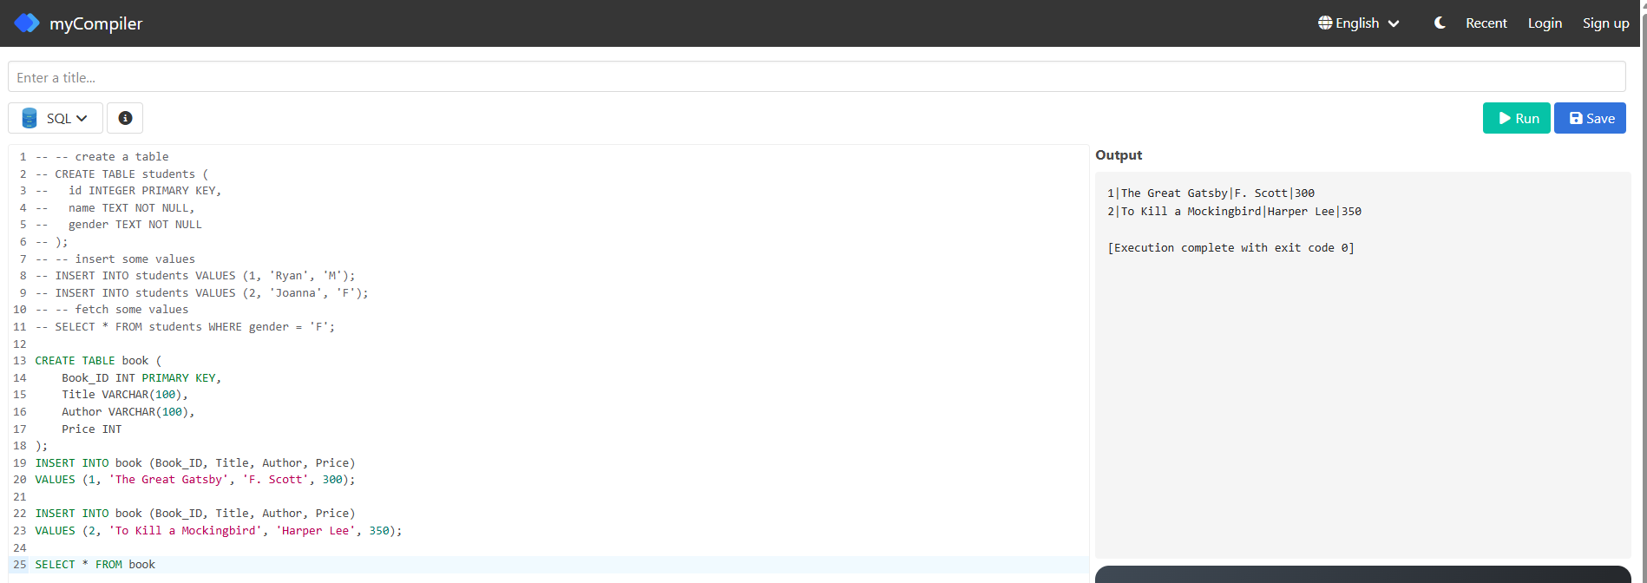

Question 2: Insert Multiple Rows Using SELECT
Create a new table employees_backup with the same structure as the employees table. Insert
all data from the employees table into employees_backup using the SELECT statement.

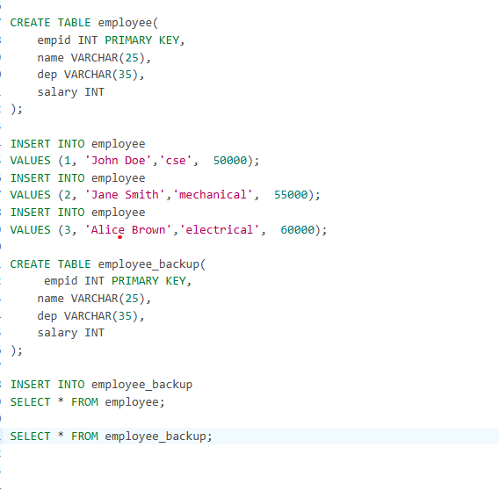

Question 3: Update Existing Data
Given a table students with the following columns:
Column Name Data Type
Student_ID NUMBER
Name VARCHAR2(100)
Grade NUMBER
Update the grade of the student with Student_ID = 101 to 90.

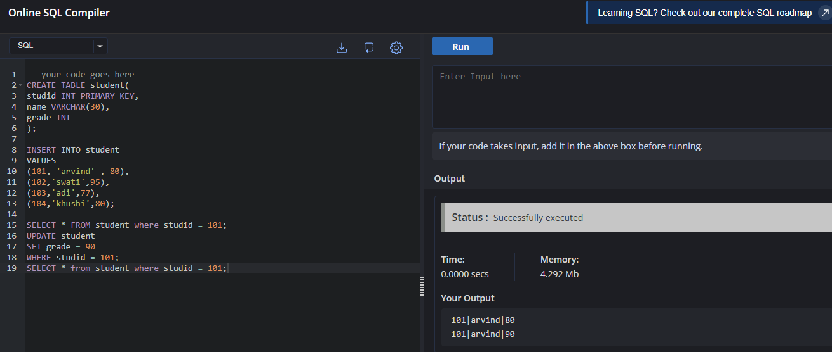

Question 4: Delete Specific Rows
In a table products, delete all rows where the Price is greater than 500.

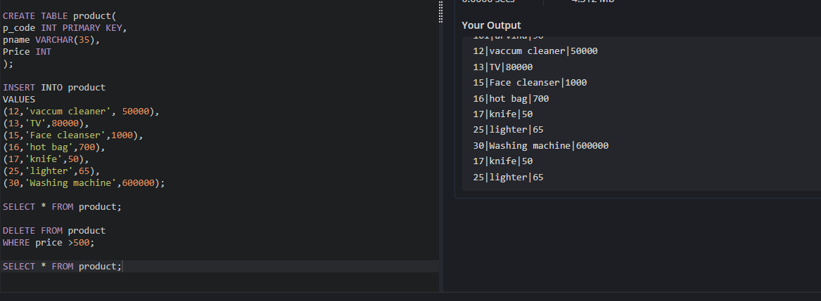

Question 5: Retrieve and Insert Data
Given two tables, employees and departments:
● The employees table has columns: Employee_ID, Name, Department_ID.
● The departments table has columns: Department_ID, Department_Name.
Insert data into a new table employee_departments (with the same columns as employees
and departments) by combining data from both tables using a SELECT statement.

